Use-Case Realization Report
UpdateDap

Issue <1.0>
Revision History
Date | Issue | Description | Author
<02/08/09> | <1.0> | <Update DAP> | <Karen Gao>

Table of Contents
1. Brief Description 4
2. Flow of Events 4
2.1 Standard Flow 4
2.2 Exceptions 4
3. Interaction Diagrams 5
3.1 Collaboration Diagram for UpdateDap 5
4. Participating Objects 5
5. Class Diagrams 6
5.1 Class Diagram for UpdateDap 6
6. Derived Requirements 6

Use-Case Realization Report
UpdateDap

Brief Description
The update of DAP shall be executed once the selection check for the existing DAP list was performed.

Flow of Events

Standard Flow
This use case covers the events of updating DAP, which is part of the Maintenance DAP package. The standard flow of events is described as below:
- The Portal Administrator shall press the button to send out a command of “updateButtonClicked” on the interface of MaintainDapPage.
- Once MaintainDapController received this request, the operation checkDapToUpdate will check if there’s Dap seleted.
- Then the operation getModuleDataList will get the Module List from object of ModuleData, and show to the MaintainDapPage through the operation showModuleDataList.
- The operation selectModuleData will select the Modules for the Dap
- Then the operation updateDapList of the MaintainDapController will update the new list of Dap object
- Once it’s done, the successful updating Dap will show to the MaintainDapPage.

Exceptions

- If there’s no selection found in Dap records, a warning message will be show to the MaintainDapPage through the operation showNoDapSelectedMsg.

Interaction Diagrams

Collaboration Diagram for UpdateDap
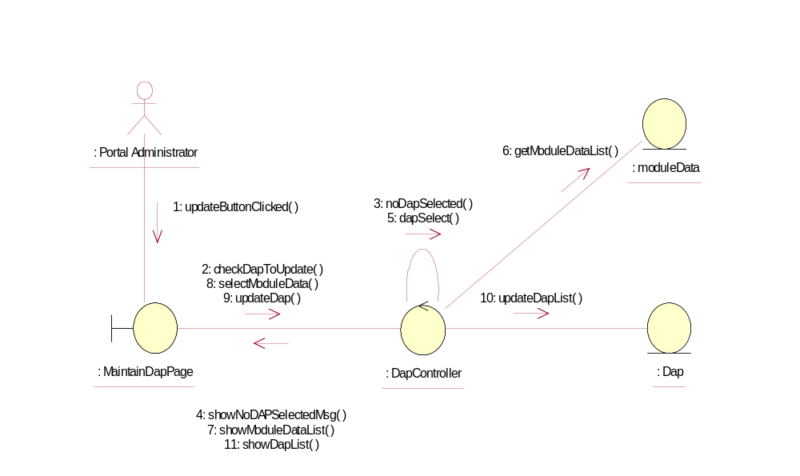

Participating Objects
: Dap
This Entity is Dap object

: DapController
This controller is to add, delete and update Dap

: MaintainDapPage
This is a page for adding, deleting, updating and displaying Dap

: moduleData
This Entity is ModuleData object

: Portal Administrator
This is the super user of the system.

Class Diagrams

Class Diagram for UpdateDap
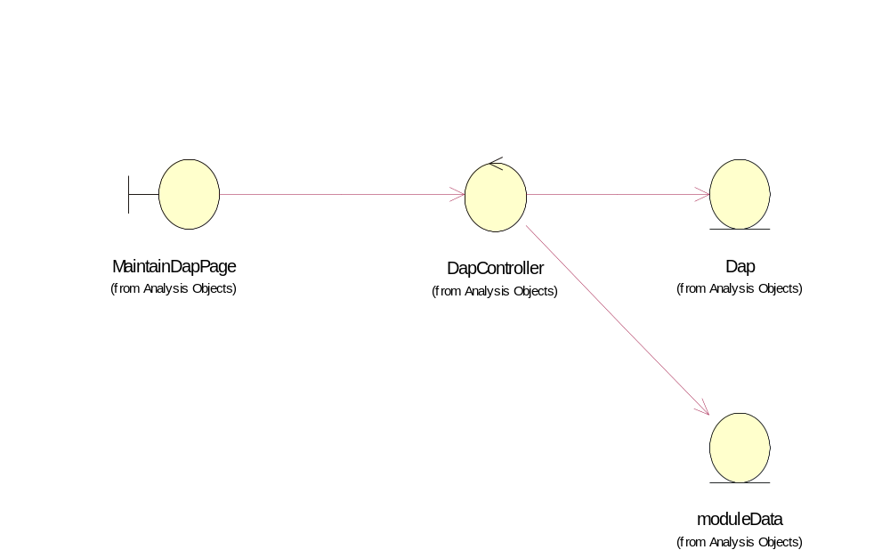

Derived Requirements
Only Portal Administrator has rights to access this page.

